Emergency Locator Transmitter (ELT) Project Report

Course- Wireless Communication
Prepared By- Md Junain Muntasir, Robert Bell
Instructor- Harry Maghera
Date- December 9, 2025

System Overview
This project presents the design of an Emergency Locator Transmitter (ELT) system using an ESP32 microcontroller, GPS module, and LoRa wireless communication. The transmitter operates in ultra-low power deep sleep mode to conserve battery life and is activated only when the emergency push button is pressed. Once triggered, the GPS module is powered through a P-MOSFET, real-time latitude and longitude data is collected, and the location is transmitted wirelessly using LoRa at 915 MHz. On the receiving end, another ESP32 with a LoRa module receives the GPS data and forwards it to the Adafruit IO cloud platform through WiFi. The user’s location is then displayed on a live interactive map, allowing real-time remote monitoring during emergency situations.

Final Hardware Design
The transmitter unit consists of an ESP32 microcontroller, GPS module, LoRa module, emergency push button, and battery power supply. The receiver also uses an ESP32 and LoRa module. The system operates at 915 MHz. The transmitter has three main operating modes: Deep Sleep Mode, Armed Mode, and Emergency Broadcast Mode. The GPS module is powered through a P-MOSFET to reduce power consumption.

Receiver Transmitter
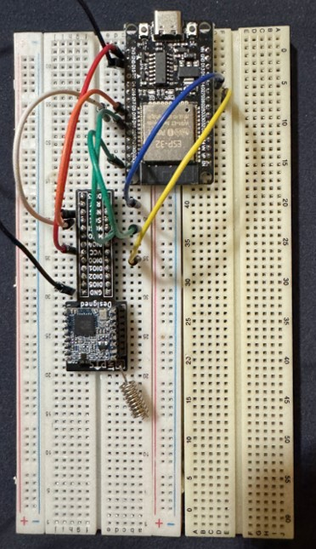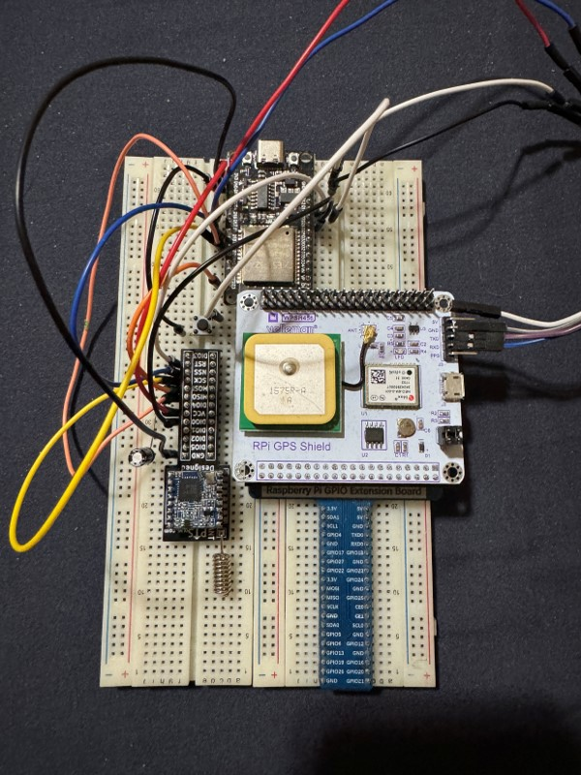

The transmitter code configures the ESP32 to operate in ultra-low power deep sleep mode until an emergency button is pressed. Once triggered, the GPS module is powered through a P-MOSFET and real-time location data is collected. The LoRa module transmits the GPS data at 915 MHz every 2 seconds. If no GPS fix is available, predefined dummy coordinates are transmitted.

Commented Source Code-Transmitter (ESP32, LoRa, GPS)
The transmitter code configures the ESP32 to operate in ultra-low power deep sleep mode until an emergency button is pressed. Once triggered, the GPS module is powered through a P-MOSFET and real-time location data is collected. The LoRa module transmits the GPS data at 915 MHz every 2 seconds. If no GPS fix is available, predefined dummy coordinates are transmitted.

#include <SPI.h>
#include <LoRa.h>
#include <TinyGPSPlus.h>
#include "esp_sleep.h"

TinyGPSPlus gps;

// ---- LoRa pin definitions ----
const int LORA_SS = 5; // NSS / CS
const int LORA_RST = 14; // RESET
const int LORA_DIO0 = 26; // DIO0

// ---- GPS UART pins ----
// RX2 = GPIO16 (ESP32 receives from GPS TX)
// TX2 = GPIO17 (ESP32 transmits to GPS RX)

// ---- GPS power control (P-MOSFET gate) ----
const int GPS_POWER_PIN = 25; // Gate of P-MOSFET via 1k resistor

// ---- Button to wake / trigger on GPIO 27 ----
const int BUTTON_PIN = 27; // Button to GND, using INPUT_PULLUP

// ---- Dummy coordinates when no GPS fix ----
const float DUMMY_LAT = 43.79560f;
const float DUMMY_LON = -79.35051f;

// ---- Payload struct (must match receiver) ----
struct Payload {
float lat;
float lon;
};

// --------- Helper: power control for GPS via MOSFET ---------
void gpsPowerOn() {
// Gate LOW => P-MOSFET ON => GPS gets 5V
digitalWrite(GPS_POWER_PIN, LOW);
delay(100); // let GPS power stabilize
}

void gpsPowerOff() {
// Gate HIGH => P-MOSFET OFF => GPS unpowered
digitalWrite(GPS_POWER_PIN, HIGH);
}

void goToDeepSleep() {
Serial.println("ELT Status: ARM Mode - Awaiting Emergency Trigger.");
Serial.println("Device in deep sleep.");
delay(200); // allow Serial to flush
esp_deep_sleep_start();
}

void setup() {
Serial.begin(9600);
delay(200);

// ---- Configure button as wake source (active LOW on GPIO27) ----
esp_sleep_enable_ext0_wakeup(GPIO_NUM_27, 0); // wake when pin goes LOW
pinMode(BUTTON_PIN, INPUT_PULLUP); // button to GND

// ---- GPS power pin setup (MOSFET gate) ----
// Default GPS OFF: set latch HIGH before pinMode to avoid glitches
digitalWrite(GPS_POWER_PIN, HIGH);
pinMode(GPS_POWER_PIN, OUTPUT);

// ---- Determine wakeup cause ----
esp_sleep_wakeup_cause_t cause = esp_sleep_get_wakeup_cause();

if (cause != ESP_SLEEP_WAKEUP_EXT0) {
// RESET / power-up / other wake → straight to deep sleep (ARM mode)
goToDeepSleep();
}

// If we reach here, we woke from EXT0 (button press = emergency trigger)
Serial.println("Transmitter Emergency Triggered");
Serial.println("Emergency Triggered Sending out GPS Data");

// ---- Turn GPS on ----
gpsPowerOn();

// ---- Start GPS UART ----
Serial2.begin(9600, SERIAL_8N1, 16, 17); // GPS on RX2/TX2

// ---- LoRa setup ----
LoRa.setPins(LORA_SS, LORA_RST, LORA_DIO0);

if (!LoRa.begin(915E6)) { // 915 MHz for your module
Serial.println("LoRa init failed!");
// If LoRa fails, turn GPS off and go back to deep sleep
gpsPowerOff();
goToDeepSleep();
}

Serial.println("LoRa TX ready.");
Serial.println("Transmitting location data every 2 seconds...");

// ---- CONTINUOUS TRANSMIT AFTER SINGLE BUTTON PRESS ----
while (true) {
// --- Read GPS for a short period (non-blocking, no long wait) ---
unsigned long start = millis();
while (millis() - start < 1000) { // ~1 second of GPS reading
while (Serial2.available()) {
gps.encode(Serial2.read());
}
}

float lat, lon;
bool dummyFlag;

if (gps.location.isValid()) {
// ----- REAL GPS DATA -----
lat = (float)gps.location.lat();
lon = (float)gps.location.lng();
dummyFlag = false;
} else {
// ----- DUMMY COORDINATES (no fix yet) -----
lat = DUMMY_LAT;
lon = DUMMY_LON;
dummyFlag = true;
}

// ---- Prepare binary payload (must match receiver struct) ----
Payload pkt;
pkt.lat = lat;
pkt.lon = lon;

// ---- Send payload over LoRa as raw bytes ----
LoRa.beginPacket();
LoRa.write((uint8_t*)&pkt, sizeof(pkt));
LoRa.endPacket();

// ---- Debug print to Serial (transmitter side) ----
String status = dummyFlag ? "Dummy" : "GPS";

Serial.print("TX packet: ");
Serial.print(lat, 6);
Serial.print(", ");
Serial.print(lon, 6);
Serial.print(" Status: ");
Serial.println(status);

// Send roughly every 2 seconds
delay(2000);
}

// (We never reach here. Device keeps transmitting until reset/power off.)
}

void loop() {
// We never run loop(): after deep sleep, code restarts from setup().
}

Commented Source Code- Sender (ESP32, LoRa, WiFi, Cloud)

The receiver code runs on an ESP32 with a LoRa module and WiFi enabled. When the system starts, it prompts the user over the serial monitor to enter the Wi-Fi SSID and password. After connecting to Wi-Fi in station mode, the ESP32 initializes the LoRa module at 915 MHz and waits for incoming packets. Each LoRa packet is expected to contain a binary Payload structure with latitude and longitude values sent by the transmitter. When a valid packet is received, the code reads the GPS coordinates, prints them to the serial monitor along with the LoRa RSSI value, and then forwards the data to two cloud services. First, it sends the latitude, longitude, and RSSI to ThingSpeak using an HTTP GET request, respecting the minimum 16-second update interval. Second, it sends the same location data to an Adafruit IO “location” feed using an HTTP POST request with a JSON body that includes value, lat, and lon fields. Timing control using millis() ensures that uploads to ThingSpeak and Adafruit IO stay within their rate limits. In this way, the receiver acts as a gateway that converts long-range LoRa packets into internet-based cloud updates for real-time visualization.

#include <SPI.h>
#include <LoRa.h>
#include <WiFi.h>

// ---------- LoRa pins ----------
const int LORA_SS = 5; // NSS (Chip Select)
const int LORA_RST = 14; // RESET
const int LORA_DIO0 = 26; // DIO0 (Interrupt)

// ---------- ThingSpeak ----------
const char* TS_SERVER = "api.thingspeak.com";
const char* TS_WRITEKEY = "MHK5W80V0728GNHA"; // <-- your ThingSpeak WRITE API key
const unsigned long TS_MIN_INTERVAL_MS = 16000; // >= 15 s

// ---------- Adafruit IO (REST over HTTP) ----------
const char* AIO_SERVER = "io.adafruit.com";
const char* AIO_USERNAME = "rabell2"; // your username
const char* AIO_KEY = "aio_YbZZ71AxkT1VOJhj9VprCgR16wJL"; // your AIO key
const char* AIO_FEED_KEY = "location"; // feed key

// Adafruit IO rate limit (free tier is 30 data points/min)
const unsigned long AIO_MIN_INTERVAL_MS = 2000; // 2 s

// ---------- State ----------
bool wifiOK = false;
unsigned long lastTSUpload = 0;
unsigned long lastAIOUpload = 0;

// ---------- LoRa payload ----------
struct Payload {
float lat;
float lon;
};

// ---------- Helpers ----------

String readLineFromSerial(const char* prompt) {
Serial.println(prompt);
Serial.print("> ");

String input = "";
while (true) {
if (Serial.available()) {
char c = Serial.read();
if (c == '\n' || c == '\r') {
if (input.length() > 0) break;
} else {
input += c;
}
}
}
Serial.println(input);
return input;
}

// ----- ThingSpeak upload -----
void sendToThingSpeak(float lat, float lon, int rssi) {
if (!wifiOK || WiFi.status() != WL_CONNECTED) {
Serial.println("Wi-Fi not connected – skipping ThingSpeak upload.");
return;
}

WiFiClient client;

String url = "/update?api_key=" + String(TS_WRITEKEY);
url += "&field1=" + String(lat, 6);
url += "&field2=" + String(lon, 6);
url += "&field3=" + String(rssi);

Serial.print("Connecting to ThingSpeak...");
if (!client.connect(TS_SERVER, 80)) {
Serial.println(" failed.");
return;
}
Serial.println(" ok.");

client.print(String("GET ") + url + " HTTP/1.1\r\n" +
"Host: " + TS_SERVER + "\r\n" +
"Connection: close\r\n\r\n");

Serial.println("ThingSpeak update sent.");
client.stop();
}

// ----- Adafruit IO upload (location feed) -----
// IMPORTANT: send JSON with lat/lon so the feed becomes a “location” feed.
void sendToAdafruitLocation(float lat, float lon) {
if (!wifiOK || WiFi.status() != WL_CONNECTED) {
Serial.println("Wi-Fi not connected – skipping Adafruit IO upload.");
return;
}

WiFiClient client;

// Build JSON body: { "value":0, "lat":xx.xxxxxx, "lon":yy.yyyyyy }
String json = "{";
json += "\"value\":0,"; // value can be whatever you like
json += "\"lat\":" + String(lat, 6) + ",";
json += "\"lon\":" + String(lon, 6);
json += "}";

String url = "/api/v2/";
url += AIO_USERNAME;
url += "/feeds/";
url += AIO_FEED_KEY;
url += "/data";

Serial.print("Connecting to Adafruit IO...");
if (!client.connect(AIO_SERVER, 80)) {
Serial.println(" failed.");
return;
}
Serial.println(" ok.");

client.print("POST " + url + " HTTP/1.1\r\n");
client.print("Host: " + String(AIO_SERVER) + "\r\n");
client.print("Content-Type: application/json\r\n");
client.print("X-AIO-Key: " + String(AIO_KEY) + "\r\n");
client.print("Content-Length: ");
client.print(json.length());
client.print("\r\n\r\n");
client.print(json);

Serial.print("Adafruit IO location JSON sent: ");
Serial.println(json);

client.stop();
}

// ---------- Setup ----------
void setup() {
Serial.begin(9600);
delay(500);

String ssid = readLineFromSerial("Enter Wi-Fi SSID:");
String pass = readLineFromSerial("Enter Wi-Fi password:");

WiFi.mode(WIFI_STA);
WiFi.begin(ssid.c_str(), pass.c_str());

Serial.print("Connecting to Wi-Fi");
unsigned long start = millis();
while (WiFi.status() != WL_CONNECTED && (millis() - start) < 20000) {
delay(500);
Serial.print(".");
}
Serial.println();

if (WiFi.status() == WL_CONNECTED) {
wifiOK = true;
Serial.print("Wi-Fi connected. IP: ");
Serial.println(WiFi.localIP());
} else {
wifiOK = false;
Serial.println("Wi-Fi timeout. Continuing without Wi-Fi.");
}

LoRa.setPins(LORA_SS, LORA_RST, LORA_DIO0);

if (!LoRa.begin(915E6)) {
Serial.println("LoRa init failed!");
while (true) { }
}

Serial.println("LoRa RX ready.");
}

// ---------- Main loop ----------
void loop() {
int packetSize = LoRa.parsePacket();

if (packetSize == sizeof(Payload)) {
Payload pkt;
LoRa.readBytes((uint8_t*)&pkt, sizeof(pkt));

int rssi = LoRa.packetRssi();

Serial.print("RX: ");
Serial.print(pkt.lat, 6);
Serial.print(", ");
Serial.print(pkt.lon, 6);
Serial.print(" RSSI: ");
Serial.println(rssi);

unsigned long now = millis();

if (now - lastAIOUpload >= AIO_MIN_INTERVAL_MS) {
sendToAdafruitLocation(pkt.lat, pkt.lon);
lastAIOUpload = now;
}

if (now - lastTSUpload >= TS_MIN_INTERVAL_MS) {
sendToThingSpeak(pkt.lat, pkt.lon, rssi);
lastTSUpload = now;
}
}
}

Detailed Results and Performance Analysis

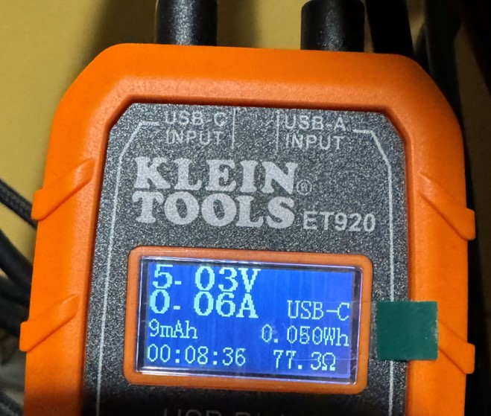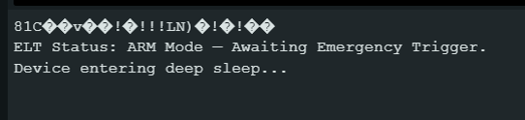
Figure 1

Figure 1 shows the transmitter in ARM mode where the ESP32 is placed into deep sleep to conserve power. In this state, the GPS and LoRa modules are powered OFF and the system waits for an external emergency trigger from the push button. This mode significantly reduces battery consumption since no wireless transmission or GPS processing occurs while the device is idle.

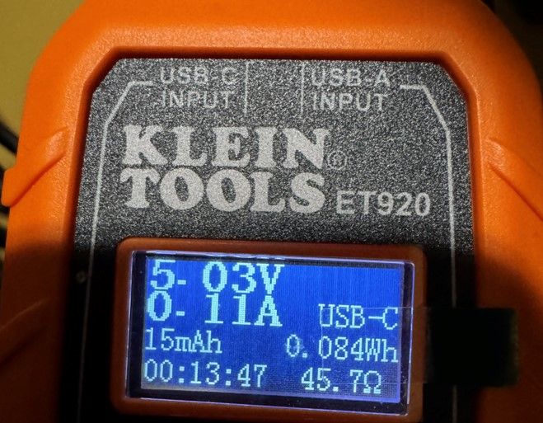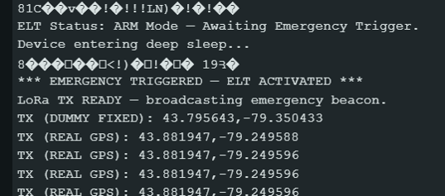

This confirms that the wake-up interrupt operation is functioning correctly. After waking up, the ESP32 enables the GPS module by driving the P-MOSFET control pin LOW. This allows the GPS module to receive power only when needed. Power gating ensures efficient battery usage by disabling the GPS during inactive states. Once powered ON, the GPS module begins acquiring latitude and longitude information. When a valid GPS fix is available, real coordinates are transmitted. If no fix is available, predefined dummy coordinates are used.

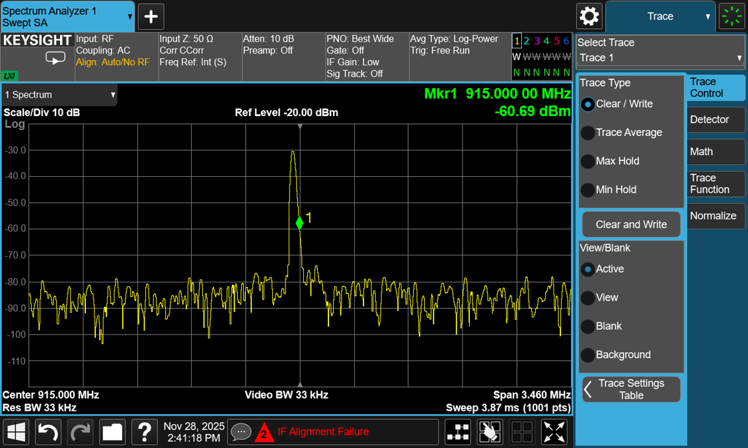

The collected GPS coordinates are transmitted wirelessly using the LoRa module operating at 915 MHz. Data is sent every 2 seconds as a binary payload. The spectrum plot confirms that the ELT transmitter is operating within the ISM band.

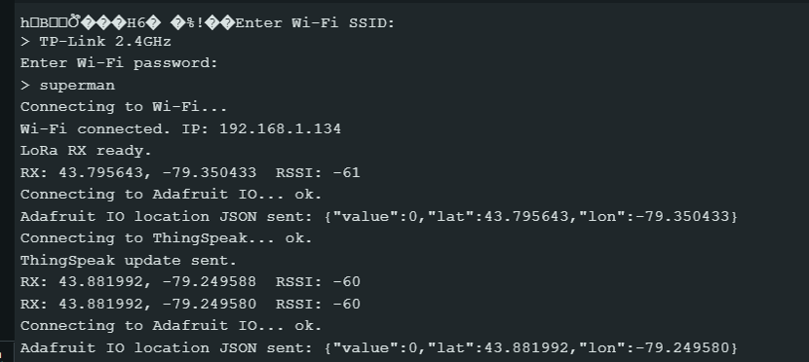
The receiver successfully establishes internet connectivity for cloud communication.
This verifies reliable long-range wireless communication between transmitter and receiver. After receiving the LoRa data, the receiver prepares the data for cloud upload using HTTP communication.

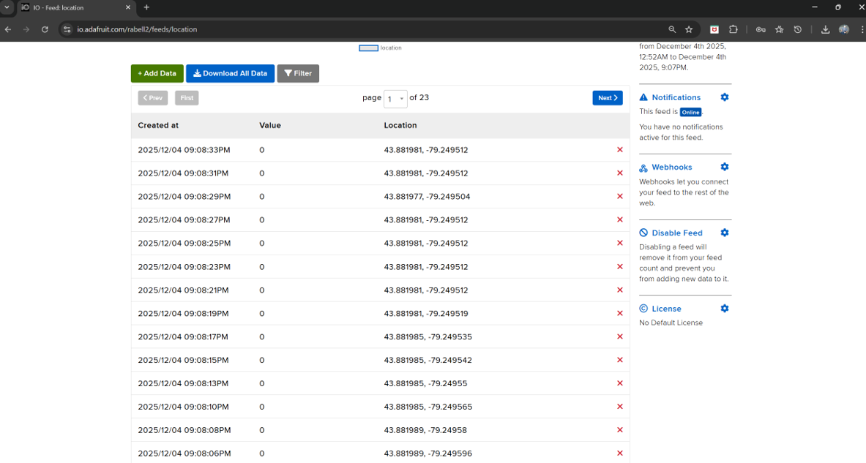
This confirms end-to-end operation from sensor acquisition to real-time cloud visualization. The successful update of live coordinates on the dashboard proves that the LoRa link, WiFi communication, and cloud integration are all functioning correctly together as a complete IoT system.
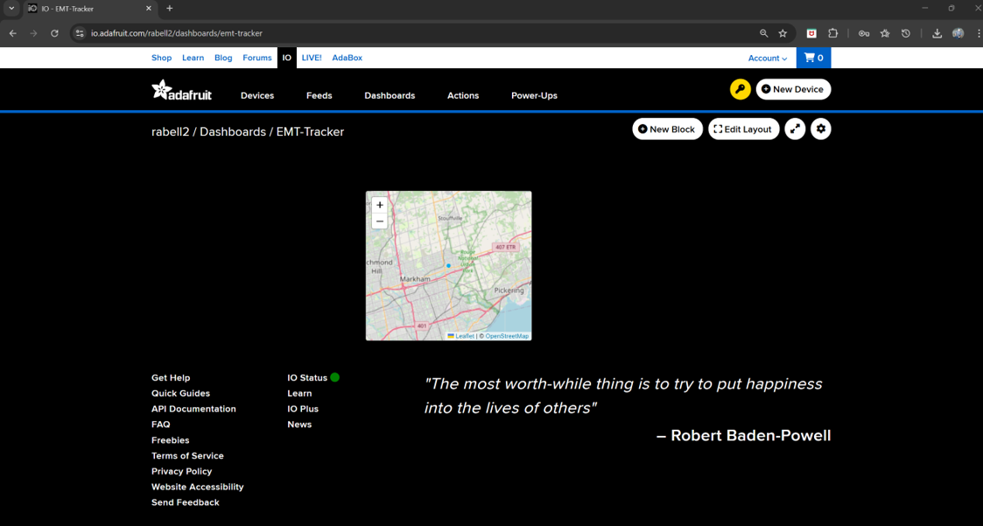
The live marker on the map updates dynamically as new latitude and longitude data is received from the LoRa transmitter through the receiver and WiFi gateway. The system operated reliably at 915 MHz with a transmission interval of approximately 2 seconds. Deep sleep mode significantly reduced battery consumption during inactive periods, extending overall battery life. LoRa communication provided stable long-range wireless performance with consistent RSSI values. The GPS module delivered accurate real-time location tracking, and the Adafruit IO cloud dashboard successfully displayed live position data. Overall, these results validate the correct and robust operation of the complete Emergency Locator Transmitter system under real-world conditions.

